LAB 6
COURSE: COMPUTER NETWORK

NETWORK SCANNING TOOL
Name: | ID:

Objective
Use NMAP to identify the network

NMAP is a port-scanning tool. It is designed to scan the ports of a network host and determine which ports are “open”. That is which ports have network services listening on them. Download NMAP official page and install it on your machine, you might want to install ZENMAP too, it’s a graphical tool bundled with NMAP. You need to refer to NMAP webpage documents for scanning basics www.nmap.org.
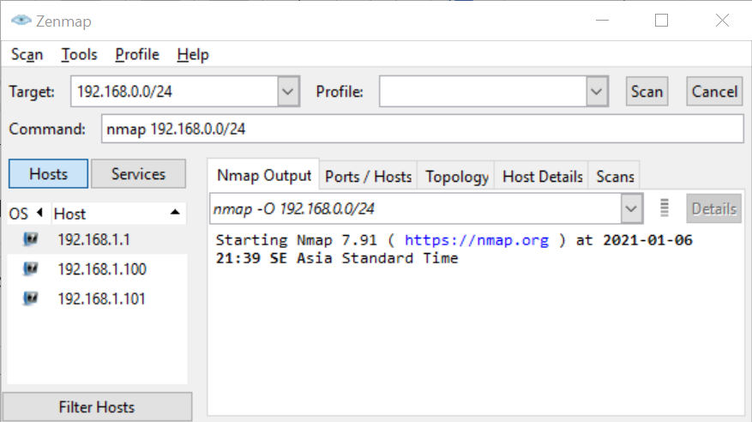

  - Identify the network address that your computer is connected
192.168.251.34
  - Do a scan to determine all running hosts in your network.
Choosing the Profile Quick scan
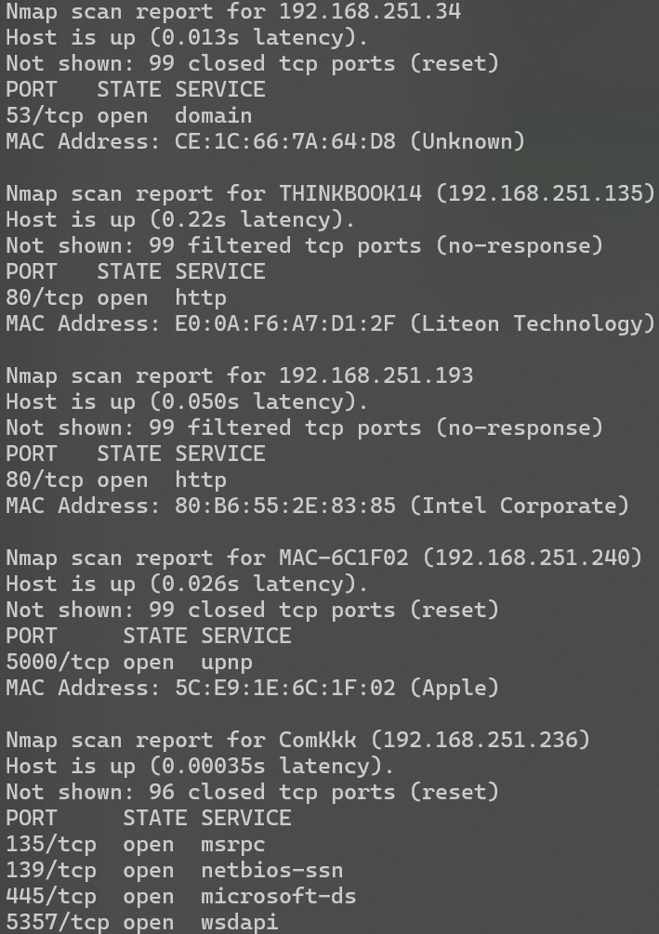
How many hosts are running? 4 hosts
Please list all the IP addresses.
- 192.168.251.236
- 192.168.251.135
- 192.168.251.240
- 192.168.251.193
  - Identify the operating system of all running host.
Using the command “nmap -O {network address/prefix}”.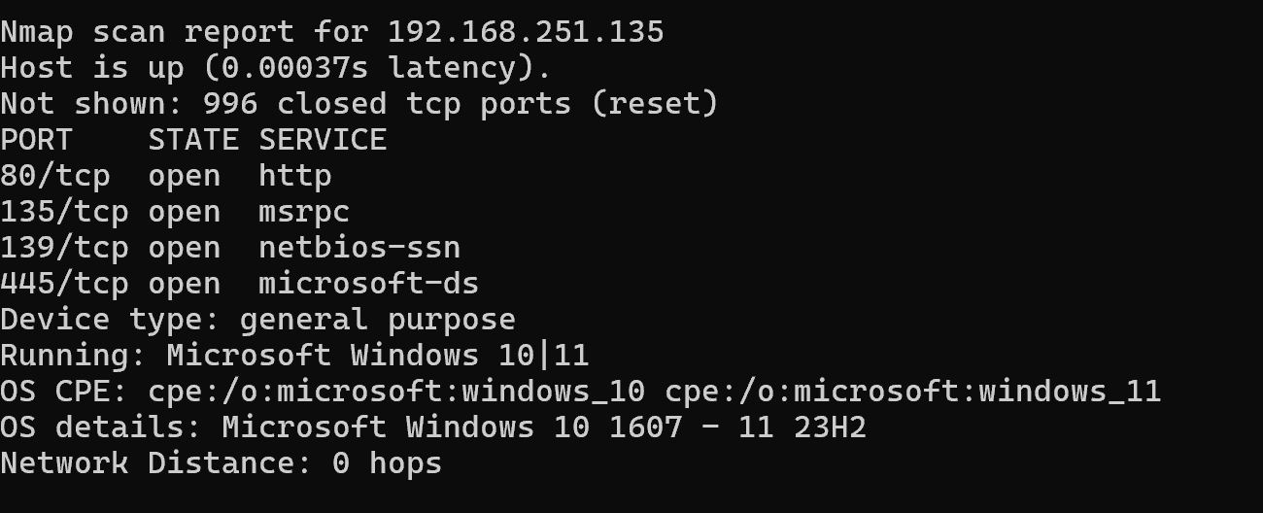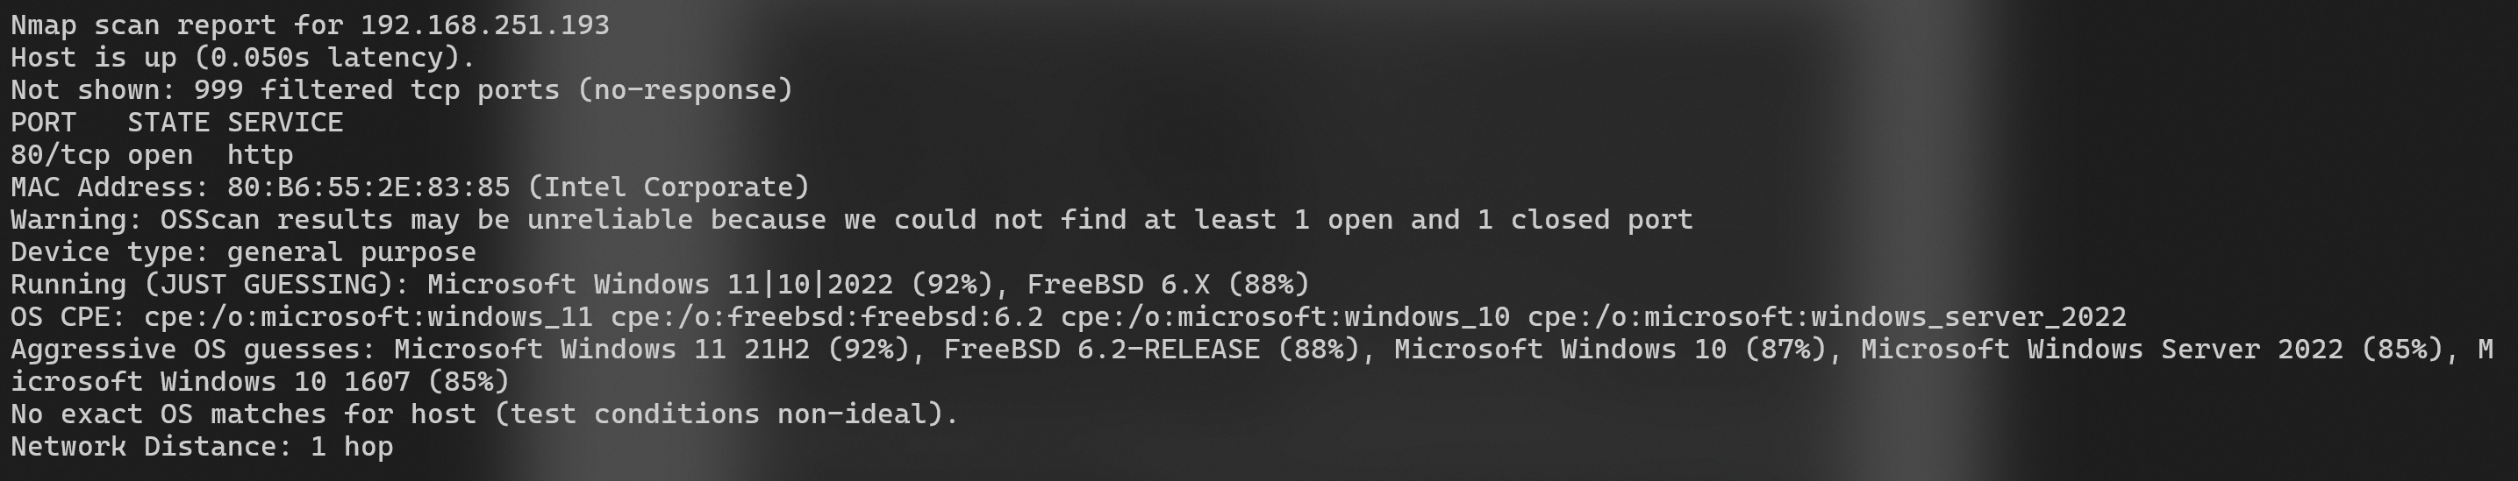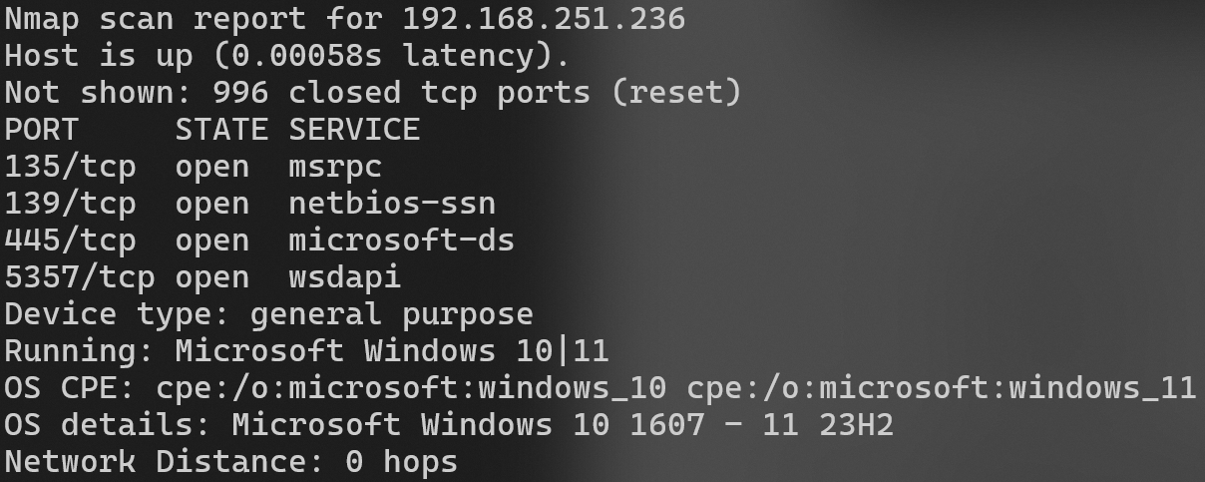
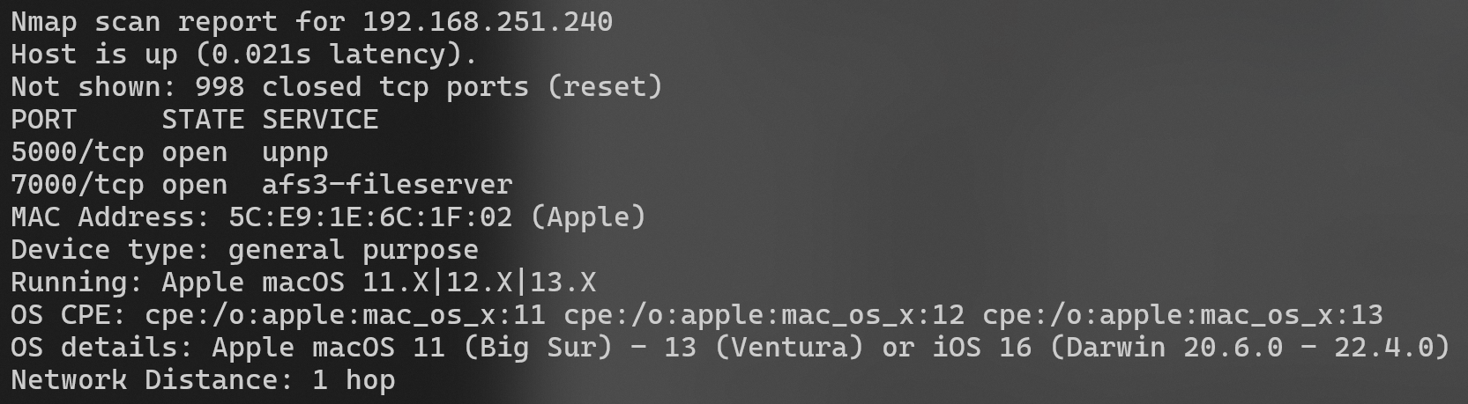
List the Operating system corresponding to the IP address
IP address | Operating system
- 192.168.251.236 | Microsoft Windows 10 1607 - 11 23H2
- 192.168.251.135 | Microsoft Windows 10 1607 - 11 23H2
- 192.168.251.240 | Apple macOS 11 (Big Sur) - 13 (Ventura)
- 192.168.251.193 | Microsoft Windows 10 1607 - 11 22H2
  - Identify the IP address of the default gateway. Find out what ports and corresponding services are open on the default gateway?
Port | Service
192.168.251.34 | 53/tcp
